EC-341 Digital System Design
BS (CE)-2021
LAB REPORT #1

Submitted By:
Reg. No. | Name
21-CE-009 | Huzaifa Shahbaz

Department of Computer Engineering
HITEC University Taxila
 | Presentation  (Format(0.5)+Title (0.5)+  Conclusion(1)+Procedure(2)+Objective(1)) | Calculation/Coding | Observation/ Program Results | Total
Total | 5 | 5 | 5 | 15
Obtained

___________________________
Lab Instructor.
Fasih Ahmad

Experiment #1
Introduction to Verilog and ModelSim
Objective: The objectives of an Introduction to Verilog and ModelSim course include equipping students with the knowledge and skills needed to design, simulate, verify, and debug digital circuits using Verilog HDL and ModelSim simulation tools.

Equipment/Software Used: ModelSim

Procedure: Introduction to Verilog: One HDL (Hardware Description Language) is Verilog. Digital electronic circuits are modeled and simulated with its help. A design can be synthesized to create gate level designs, which are subsequently translated to physical design, once it has been tested, simulated, and prepared for "tape-out" to the fabrication facility. Verilog HDL is sometimes thought of as the code that embodies the greatest level abstraction available for electronic circuits. It differs from general-purpose programming languages in that hardware modeling is its exclusive aim. Thus, you can specify registers, wires, gates, clocks, etc. in Verilog. When you want to simulate and verify hardware specifications before synthesizing the circuit, it is quite helpful and can save a lot of time. Verilog Abstraction Level 1. Switch (Transistor) Level: The switch level, which refers to the capacity to represent the circuit as a netlist of transistor switches, is the lowest level of abstraction for a digital HDL. A more comprehensive modeling technique that can identify a few more electrical issues when transistors are utilized in this manner. Little-used now that most circuits aren't constructed in this manner. 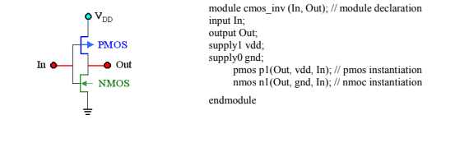 - 2.Gate (Structural) Level: The capacity to represent the circuit as a netlist of simple logic gates and functions is known as the gate level, which is a marginally higher abstraction. The gates have multiple scalar inputs and one scalar output. 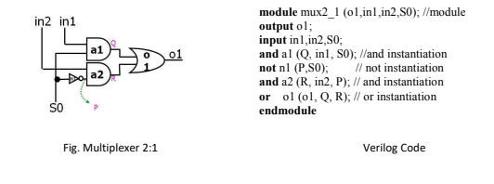 3.Data Flow Level: The gate level modeling approach is particularly effective for small circuits because it allows the designer to instantiate and link each gate separately. On the other hand, a complicated design has a very high gate count. It is therefore wise to implement the function at a level above the gate level. With the advancement of logic synthesis tools, dataflow modeling has gained popularity as a design methodology. With this method, the circuit designer can focus on improving data flow within the circuit. 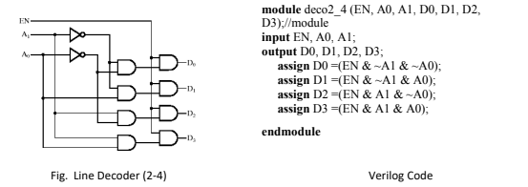 4. Functional and Algorithmic Level (Behavioral Modeling): The designer can express the functionality of the design in an algorithmic way with Verilog. Stated differently, the circuit designer explains how the circuit behaves. Writing the logic in the C language is the abstraction used in this modeling. Procedural statements in Verilog behavioral models are used to alter variables of the previously mentioned data kinds and control the simulation. The activity always begins at the initial control construct. A distinct activity flow is initiated by each always statement and each starting statement. Every activity flow is concurrent, enabling the user to simulate the hardware's intrinsic concurrency. 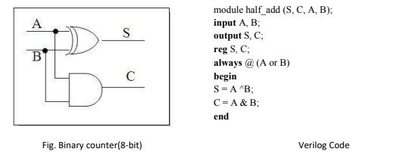 5. Register transfer Level (RTL Modelling): Describes the data and control signals that flow within and across functional units to describe a system. Using HDL models of registered circuits and the signals that flow between them—such as memory, flip flops, latches, shift registers, and so forth—you can create behavioral design concepts. Behavioral and data flow modeling are combined in RTL, which ought to be synthesizable. Compared to behavior hardware description, RTL description is less dependent on technology and more sophisticated. 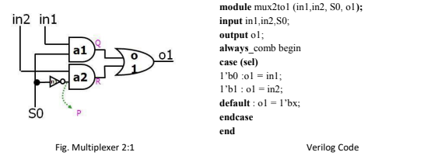

Tasks
Task #1: Write a Gate Level Verilog code to find 1’s complement of three-bit numbers. CODE: 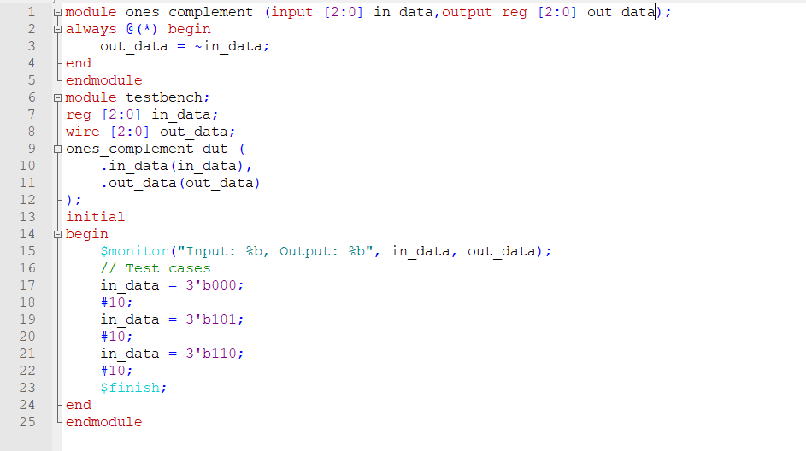
OUTPUT: 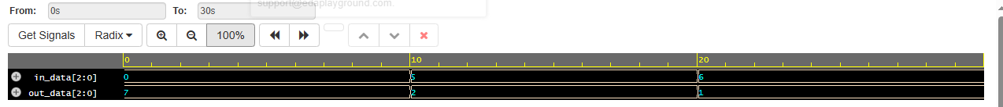
Task #2: Write a Gate Level Verilog code for Half Adder and write code for test bench as well. Simulate the Adder for different set of inputs. Attach waveform screenshots and Verilog code. CODE: 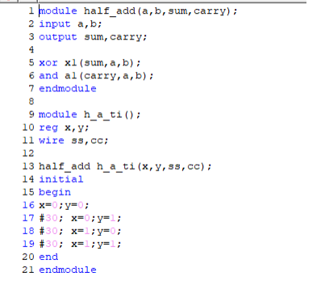 OUTPUT: 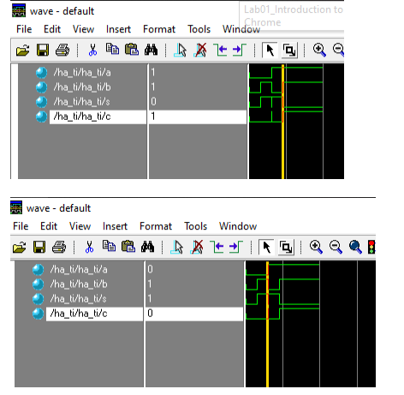

Task #3: Write code for above task for Full Adder as well. CODE: 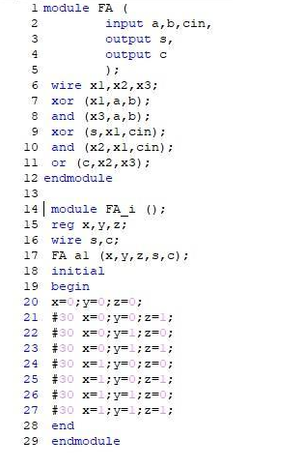 OUTPUT: 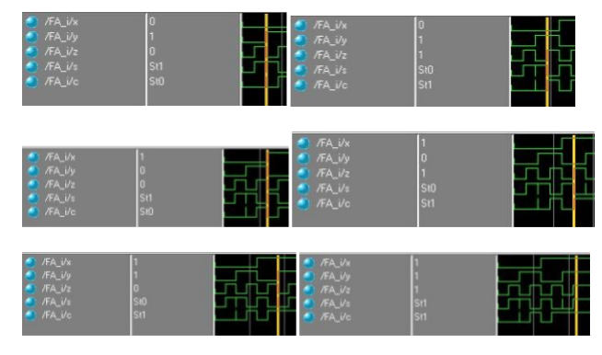
Conclusion: In conclusion, the introduction to ModelSim and Verilog offers a comprehensive initiation into digital design, showcasing gate-level implementations like half adder, full adder, and one's complement arithmetic, laying a robust foundation for hardware description and simulation proficiency.

